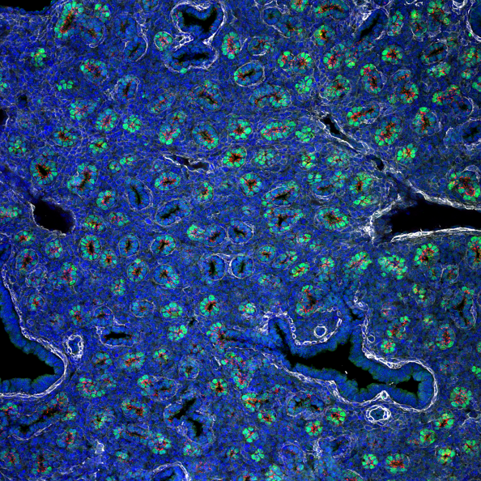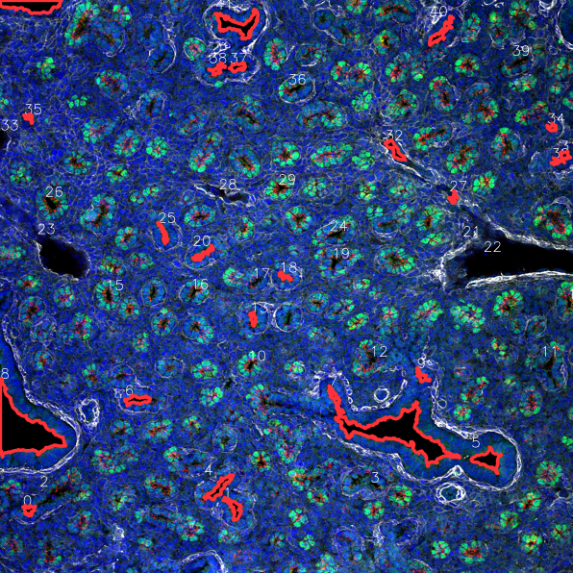

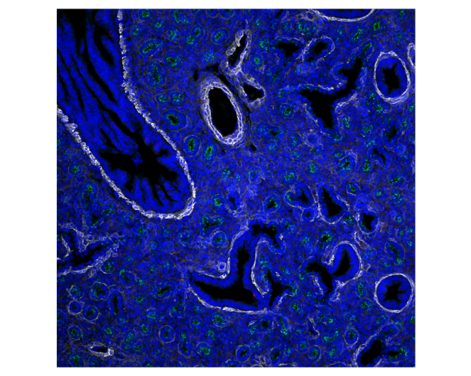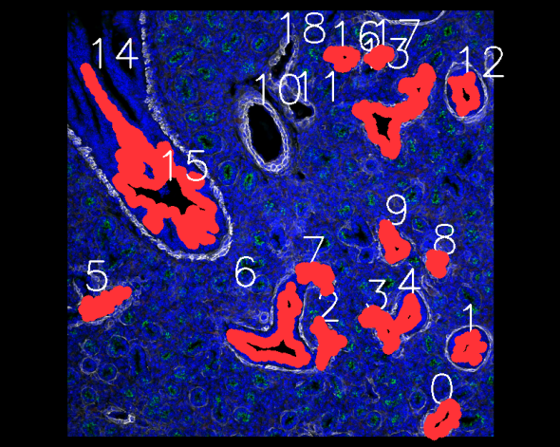

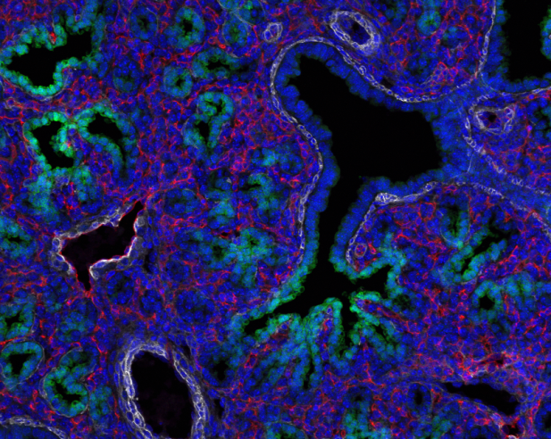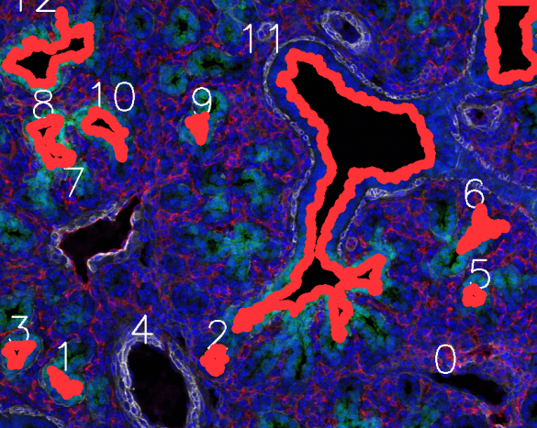

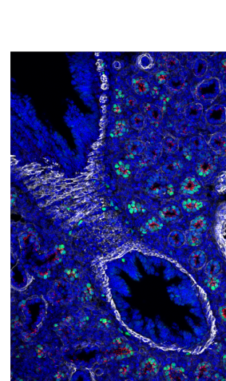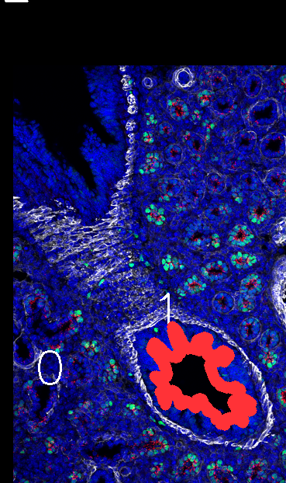

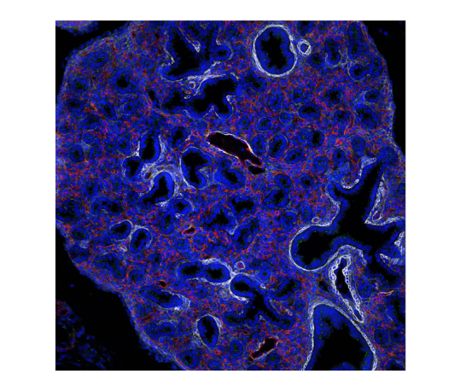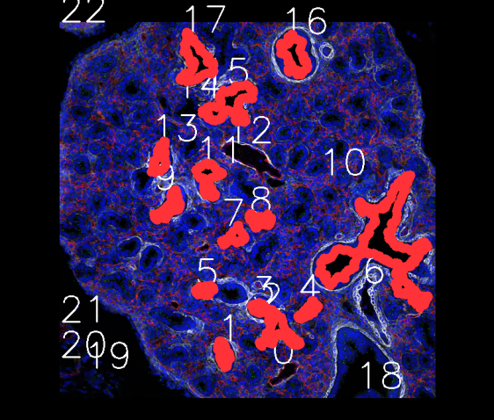

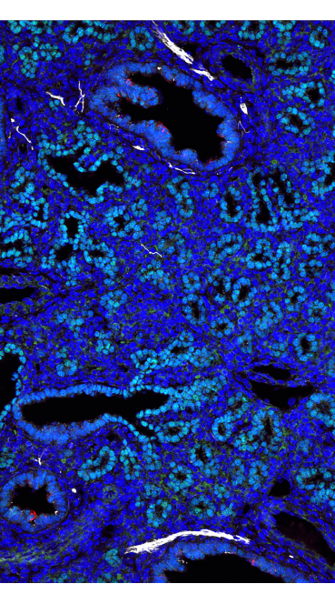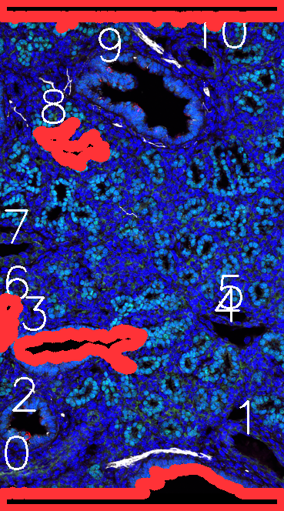

##Identifying Bronchioles from Veins with Red thick lines

import cv2

import numpy as np

import matplotlib.pyplot as plt

%matplotlib inline

###Improved algorithm

##Identifying Bronchioles from Veins with Red thick lines

filename=str("C:/Users/PABLO ORTIZ/ImageWeek85.png")

orim=cv2.imread(filename)

im = orim

im = cv2.cvtColor(im, cv2.COLOR_BGR2RGB)

orim = cv2.cvtColor(orim, cv2.COLOR_BGR2RGB)

imgray = cv2.cvtColor(im,cv2.COLOR_RGB2GRAY)

T=10

# find contours

finalcontours = []

thresh = cv2.inRange(im, np.array([0,0,0]), np.array([25,25,25]))

contours, hierarchy = cv2.findContours(thresh,cv2.RETR_CCOMP,cv2.CHAIN_APPROX_SIMPLE)

for i in range(0, len(contours)):

a = cv2.contourArea(contours[i])

if (a>300 and a<100000):

finalcontours.append(contours[i])

mask = np.zeros(imgray.shape,np.uint8)

for ia in range(0, len(finalcontours)):

cv2.drawContours(mask,finalcontours,ia,(250,220,55),thickness=T, lineType=2,maxLevel = 0)

cnt=finalcontours[ia]

cv2.drawContours(mask,[cnt],0,0,-1)#delete the contour area from the mask

plt.figure(figsize=(20, 10))

print(ia)

plt.imshow(mask,cmap='gray')

#find convex hull

for i in range(0, len(finalcontours)):

hull = [cv2.convexHull(cnt) for cnt in finalcontours]

im=orim

orim=cv2.imread(filename)

orim = cv2.cvtColor(orim, cv2.COLOR_BGR2RGB)

#draw convex hull

for ia in range(0, len(hull)):

mask = np.zeros(imgray.shape,np.uint8)

temp2 = cv2.drawContours(mask,finalcontours,ia,(100,100,100),thickness=T, lineType=2,maxLevel = 0)

cnt=finalcontours[ia]

cv2.drawContours(mask,[cnt],0,0,-1)#delete the contour area from the mask

mean_val = cv2.mean(orim,mask = mask)

a = cv2.contourArea(hull[ia])

x,y,w,h = cv2.boundingRect(cnt)

font = cv2.FONT_HERSHEY_SIMPLEX

cv2.putText(im,str(ia),(x,y), font, 2,(255,255,255),2)

if (mean_val[2]-10>mean_val[0] and mean_val[1]-5>mean_val[0]) and mean_val[0]<35:

temp2 = cv2.drawContours(im,finalcontours,ia,(255,50,55),thickness=13, lineType=1,maxLevel=0)

plt.imshow(im)

cv2.imwrite("Segmented" + filename.split("/")[-1],im)